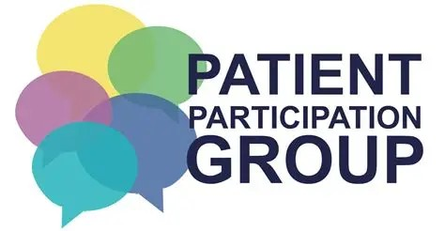

Would you like to be involved in Leadgate Surgery's patient participation group?

We are looking for expressions of interests from patients who are registered at the surgery, who have a keen interest in the local community and a passion for service improvement.

This will be an opportunity for patients to deliver new ideas and suggestions to the surgery, and for the surgery to share updates and information.
If this is something you would be interested in, please contact the surgery via email: nencicb-cd.a83636@nhs.net.

Or contact our reception team on 01207 583555 and a member of the care coordinator team will contact you to discuss further.

